Automated Network Request Management in ServiceNow
Technology Stack & Architecture Overview
Date | 09 September 2026
Student Name | Ravipati Sri Sai Deepthi
Project Name | Automated Network Request Management in ServiceNow
Maximum Marks | 4

1. Architecture Summary
The Automated Network Request Management in ServiceNow project is developed using the native capabilities of the ServiceNow platform. The solution provides a structured process for submitting and processing network requests.
A requester submits a Network Request through the ServiceNow Service Portal. The submitted request starts the configured workflow automation, which processes the request information and creates a corresponding record in the Network Database. The request is then sent for approval. Based on the approval decision, the workflow updates the record and sends the required notification.
The solution does not depend on external applications, APIs, machine-learning models, or third-party services.

2. Layer-by-Layer Breakdown
Layer | Purpose | Technology Used
User / Client Layer | Provides the interface through which the requester accesses and submits the network request. | ServiceNow Service Portal
Service Catalog Layer | Provides the Network Request catalog item and collects the information required from the requester. | ServiceNow Service Catalog
Form Validation Layer | Handles mandatory fields and controls field behaviour based on the values entered by the requester. | Catalog Configuration, UI Policies / Client-side configuration
Automation Layer | Processes the submitted request automatically, creates the database record, sends the approval request, handles the decision, and updates the record. | ServiceNow Workflow / Flow Designer
Data Layer | Stores the submitted network request information and maintains the request status and approval information. | Custom Network Database Table
Approval Layer | Sends the created network request for review and captures the approver's decision. | ServiceNow Approval
Decision Layer | Determines the next step based on whether the request is approved or rejected. | If/Else workflow logic
Notification Layer | Sends email notifications to the configured users or stakeholders during the request process. | ServiceNow Email / Workflow Notification
Security Layer | Controls access to the network request records based on authorised users and roles. | ServiceNow Roles and ACLs
Runtime Environment | Provides the environment in which the application is configured, tested, and demonstrated. | ServiceNow Personal Developer Instance (PDI)
External Integration Layer | No external application or third-party system is required for the implemented solution. | Not applicable
AI / Intelligence Layer | No AI, machine-learning, or predictive functionality is included in the current project. | Not applicable

3. Architecture Diagram
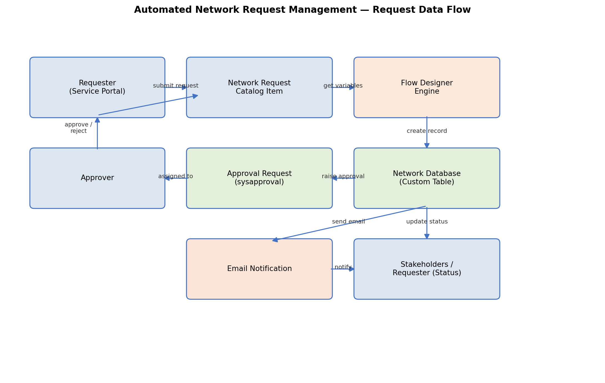
Figure 1: Request flow across the ServiceNow components listed above.

4. Component Interaction

Service Portal
The Service Portal acts as the entry point for the requester. The requester accesses the Network Request catalog item and provides the required information.

Network Request Catalog Item
The catalog item collects the network request information entered by the requester. Mandatory fields and configured form behaviour help ensure that the required information is provided before submission.

Workflow Automation
After submission, the configured ServiceNow workflow automation processes the request. It retrieves the submitted information, creates the corresponding Network Database record, initiates the approval process, evaluates the approval result, and performs the required record updates.

Network Database
The custom Network Database table stores the request information in a structured ServiceNow record. It also maintains information related to the request status and approval outcome.

Approval
The approval step sends the network request to the configured approver. The approver reviews the request and provides an approval or rejection decision.

If/Else Decision
The workflow evaluates the approval result using conditional logic. The appropriate branch is executed depending on whether the request is approved or rejected.

Record Update
After the approval decision, the Network Database record is automatically updated so that the latest status is available for tracking.

Notification
The configured notification step sends an email to the relevant recipients, keeping them informed about the request process or outcome.

5. Notes on Scope
- The solution is implemented entirely within the ServiceNow platform.
- No external REST or SOAP API integration is used.
- No third-party application or external database is connected to the project.
- No AI, machine-learning, or predictive component is included.
- The workflow is designed specifically to automate the network request lifecycle.
- Development, configuration, testing, and demonstration are performed in a ServiceNow Personal Developer Instance.
- The architecture focuses on request submission, automated processing, database record creation, approval, decision handling, status update, and notification.

